Adding your Extension List in CA

Step 1
From the “Contact” tab select “Add a Contact

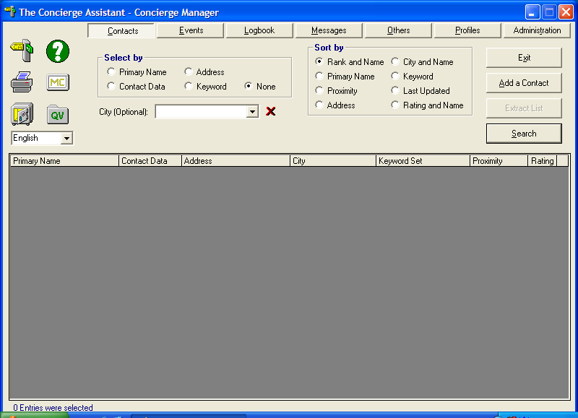

Step 2
Fill out the information as follows: “Primary Name”= First name Last name, “Contact Data”=Extension number, “Address”=Department, “Cross Streets”=LEAVE BLANK,
“City”=Title
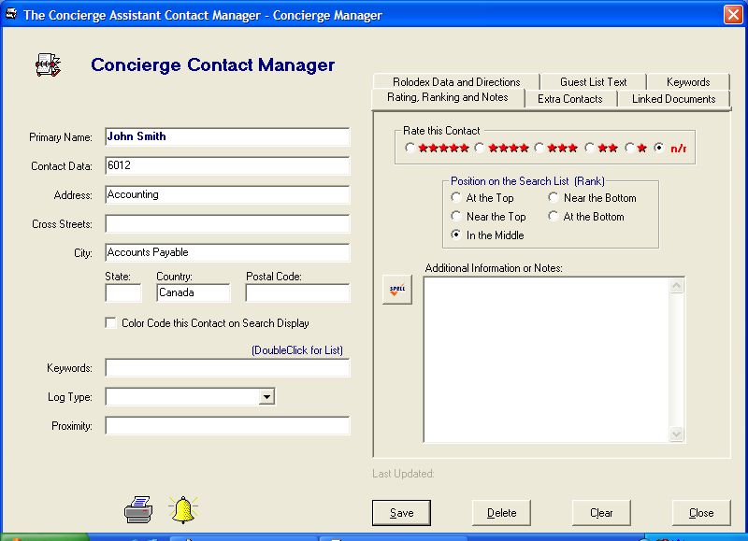
Step 3
Select the keyword “Telephone” from the “Keyword” tab on the upper right side of the entry and click “Save” and “Close”

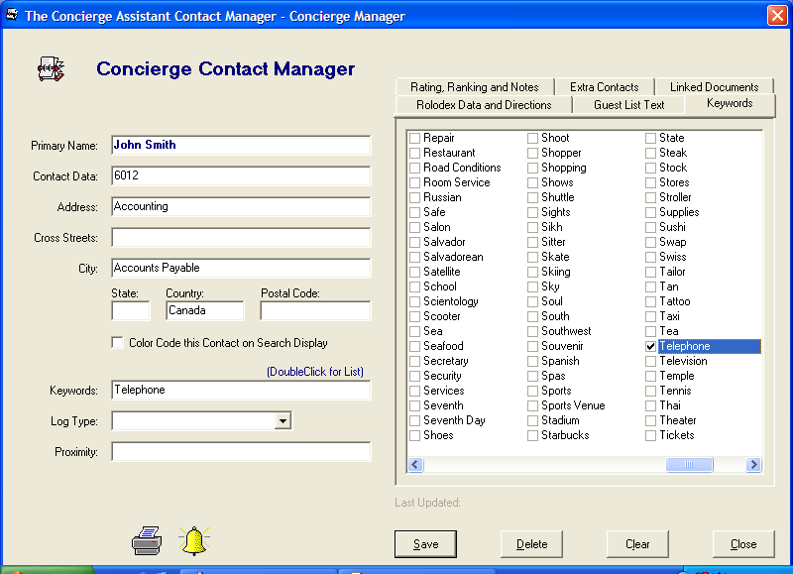

Step 4
If you “select by” Keyword Telephone you will see your Extension List like this.

